SEC : A FILE SYSTEM BATCH : A3

REG: 190905513 LAB 04 NAME: MOHAMMAD DANISH EQBAL

LAB EXERCISES:

1. Write a C program to find the inode number of an existing file in a directory. Take the input as filename and print the inode number of the file.

Program:

#include <sys/types.h>
#include <sys/stat.h>
#include <unistd.h>
#include <stdio.h>
#include <stdlib.h>
void help() { printf("USAGE: inode [name_of_file]\n");
}
int main(int argc, char * argv[]) { if ( argc != 2 ) { help(); exit(EXIT_FAILURE);
}
struct stat curr_stat;
int r_val = lstat( argv[1], &curr_stat ); if ( r_val < 0 ) { perror("lstat"); exit(EXIT_FAILURE);
}
printf("Inode number: %ld\n", curr_stat.st_ino);
}

Output:

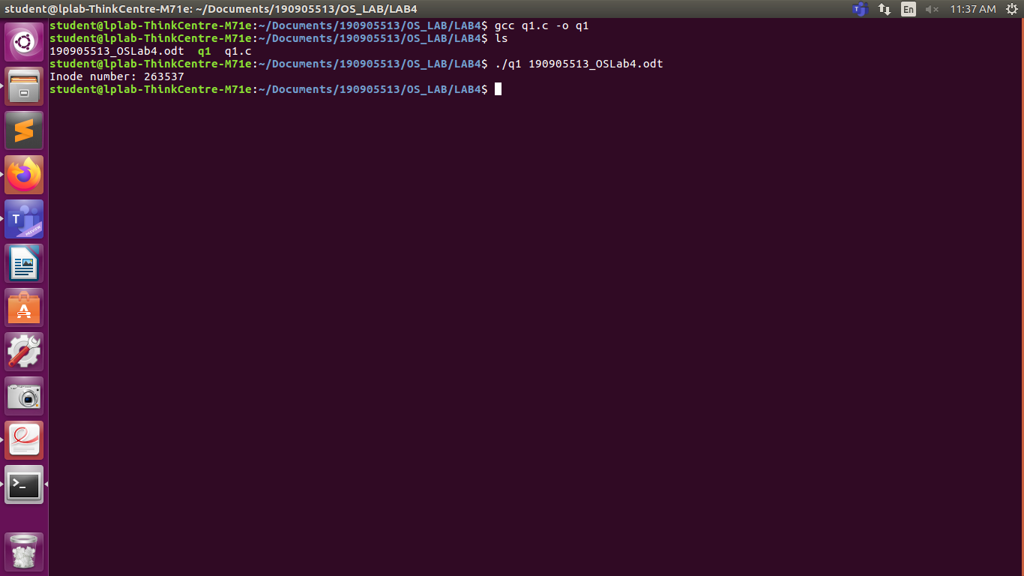

2. Write a C program to print out the complete stat structure of a file.

Program:

#include <sys/types.h>
#include <sys/stat.h>
#include <unistd.h>
#include <stdio.h>
#include <stdlib.h>
#include <time.h>
#include <pwd.h>
#include <grp.h>
void help() { printf("USAGE: stat [name_of_file]\n");
}
void pp(int r_val, char * str) { if ( r_val == 0 ) { printf("-");
} else { printf("%s", str);
}
}
void print_filetype(mode_t m) { if ( S_ISREG(m) ) { printf("Regular file");
} else if ( S_ISDIR(m) ) { printf("Directory");
} else if ( S_ISCHR(m) ) { printf("Character device");
} else if ( S_ISBLK(m) ) { printf("Block device");
} else if ( S_ISFIFO(m) ) { printf("Named pipe");
} else if ( S_ISLNK(m) ) { printf("Symbolic link");
} else if ( S_ISSOCK(m) ) { printf("Socket");
}
}
int main(int argc, char * argv[]) { if ( argc != 2 ) { help(); exit(EXIT_FAILURE);
}
struct stat curr_stat;
struct passwd * file_usr = NULL;
struct group * file_grp = NULL;
int r_val = lstat( argv[1], &curr_stat );
if ( r_val < 0 ) { perror("lstat"); exit(EXIT_FAILURE);
}
mode_t m = curr_stat.st_mode;
printf("Inode number: %ld\n", curr_stat.st_ino); printf("Device id: %ld\n", curr_stat.st_dev); printf("Mode: %d\n", m); printf("File permissions: ");
pp( m & S_IRUSR, "r" );
pp( m & S_IWUSR, "w" );
pp( m & S_IXUSR, "x" );
pp( m & S_IRGRP, "r" );
pp( m & S_IWGRP, "w" );
pp( m & S_IXGRP, "x" );
pp( m & S_IROTH, "r" );
pp( m & S_IWOTH, "w" );
pp( m & S_IXOTH, "x" );
printf("\n");
printf("File type: ");
print_filetype(m);
printf("\n");
file_usr = getpwuid(curr_stat.st_uid);
if ( file_usr == NULL ) { perror("getpwuid"); exit(EXIT_FAILURE);
}
file_grp = getgrgid(curr_stat.st_gid); if ( file_grp == NULL ) { perror("getgrgid"); exit(EXIT_FAILURE);
}
printf("UID: %d(%s)\n", curr_stat.st_uid, file_usr->pw_name); printf("GID: %d(%s)\n", curr_stat.st_gid, file_grp->gr_name); printf("Size: %ld bytes\n", curr_stat.st_size);
printf("Block size: %ld\n", curr_stat.st_blksize);
printf("No of blocks used: %ld\n", curr_stat.st_blocks); printf("Last access time: %s", ctime(&curr_stat.st_atime)); printf("Last modified time: %s", ctime(&curr_stat.st_mtime));
printf("Last status change time: %s", ctime(&curr_stat.st_ctime)); free(file_usr); free(file_grp);
}

Output:
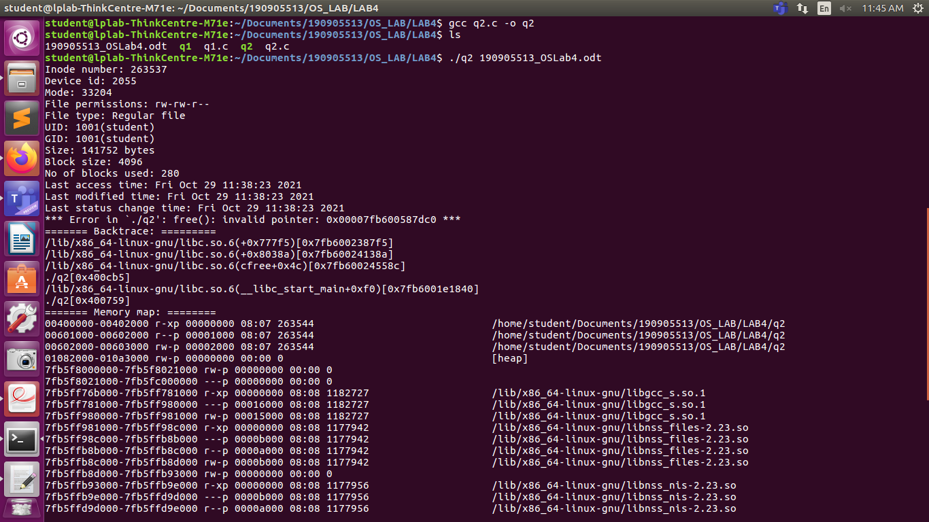

3. Write a program to create a new hard link to an existing file and unlink the same. Accept the old path as input and print the newpath.

Program:

#include <sys/types.h>
#include <sys/stat.h>
#include <unistd.h>
#include <stdio.h>
#include <inttypes.h>
#include <stdlib.h>
void main(int argc, char* argv[])
{
if(argc<2)
{
printf("Insufficient arguments\n");
return;
}

char new_path[100]="q3.c";
struct stat start;
int ret1 = stat(argv[1],&start);
printf("Number of hard links:%ld\n", start.st_nlink);
system("ls");
printf("Linking..\n");
int ret2 = link(argv[1],new_path);
struct stat intermediate;
int ret3 = stat(argv[1],&intermediate);
printf("Number of hard links:%ld\n", intermediate.st_nlink);
printf("New path:%s\n",new_path);
system("ls");
int ret4 = unlink(argv[1]);
struct stat ending;
int ret5 = stat(new_path,&ending);
printf("Unlinking\n");
printf("Number of hard links after unlinking:%ld\n", ending.st_nlink);
system("ls");
}

Output:
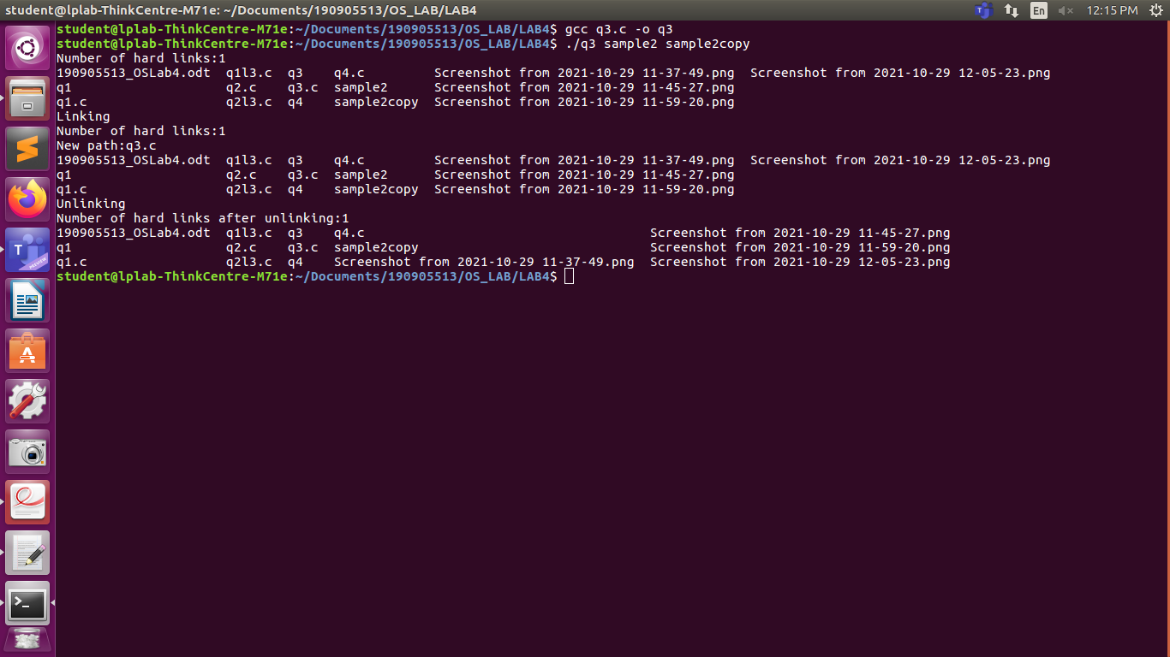

4. Write a program to create a new soft link to an existing file and unlink the same. Accept the old path as input and print the newpath.

Program:

#include<sys/types.h>
#include<sys/stat.h>
#include<unistd.h>
#include<stdio.h>
#include <inttypes.h>
#include<stdlib.h>
void main(int argc, char* argv[])
{
if(argc<2)
{
printf("Insufficient arguments\n");
return;
}
char new_path[100]="q4.c";
struct stat start;
int ret1 = stat(argv[1],&start);
system("ls");
printf("Linking\n");
int ret2 = symlink(argv[1],new_path);
struct stat intermediate;
int ret3 = stat(argv[1],&intermediate);
printf("New path:%s\n",new_path);
system("ls");
int ret4 = unlink(argv[1]);
struct stat ending;
int ret5 = stat(new_path,&ending);
printf("Unlinking\n");
system("ls");
}

Output:

